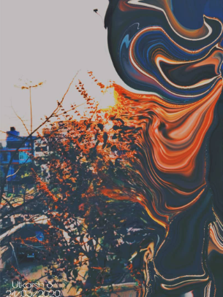
As the one clear picture of the world,as rigid as it used to be, now melts and spirals around a single news,
As the common lives come to a standstill, while the governments rush to control the catastrophe,
As our bodies lay resting on our couches, our minds now swirl into their depths,
As the economy that had seen recent bulls, now grapples with a giant bear,
And as the fear slowly takes over,
Yet rays of hope and assurance that everything will be just fine penetrate through the despair of isolation, we think, if this reality, that we have fabricated, really does matter.
If imposition of ideologies, with wicked and crooked manners really mean a thing, when nature itself doesn't see any difference while erasing it.
Few are still concerned about religion, about capitalism,communism or territories. Most,busy in saving that which is the root of all, human life. And ironically, when human lives are taken for the same human made issues, but strategically, and in a differentiated manner, it is as if it were the goal of their lives.
The subordinates of life become more important than life itself.

